[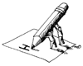](http://school.discovery.com/clipart/clip/handwrit1.html) ***O’Lynnger - Journal Responses*** 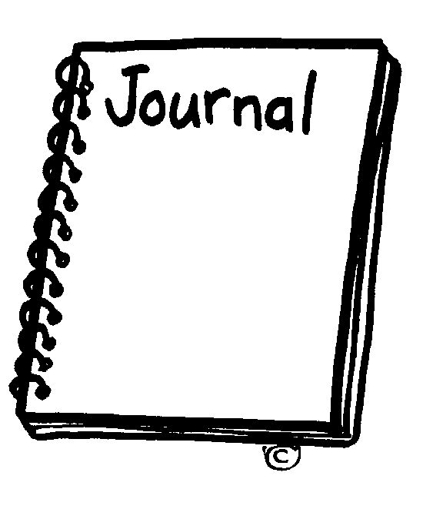

ASSIGNED:__________

DUE:__________

TEXT:___________________________________________By________________________________

***A.***

* ***LAbel*** JoURNAl-response ***TyPE*** at the ***top*** of each response
* ***Write*** word/Line ***total*** at the ***bottom of each page***
* ***Use PAGE NUMBERS***  FOR ***cITATIONS***
* ***CHOOSE***  **4** of the following Responses (100 points/25 Points per jouRnal)

***B.***

* 20 ***Vocabulary words*** + definitions (100 points)

***C.***

* ***CHaracter weB*** (following Format); At least **10 characters** (100 points)

**JOURNAL RESPONSES**

***Dialectical (Dialogue) Journal🡪*** Select a meaningful passage of at least 25 words and copy it on the left quarter of the page. Use the ¾ of the page you have left to respond, to question, to make personal connections, to evaluate, to reflect, to analyze and/or to interpret. The response must be a minimum of 150 words.

***Problem-Solution Journal🡪*** Identify a problem that exists within the chapter/the novel, then suggest and explore possible solutions. Divide the paper in half. Label the left side “Problem(s)” and the right side “Resolving the Problem(s)”. Brainstorm possible alternatives, discuss a probable solution, anticipate stumbling blocks and propose arguments in favor of a proposed solution. Minimum 200 words.

***Speculation about Effects/Prediction Journal🡪*** Examine events and speculate about the possible long term effects resulting from these events. Divide the paper in half. On the left side, record “What Happened”. On the right side, speculate about “What Might/Should Happen as a Result of This Action”. Make sure your answers are thorough and thoughtful, not obvious and/or superficial. Minimum 200 words.

***Subjunctive Journal🡪*** Express supposition or possibility about events or character. Begin with a supposition: “If” a character had (or had not) done a certain thing. “Then” _________ would (or would not) have happened. Develop your supposition and support your assertion in a paragraph. Minimum 200 words.

***Open Mind Journal🡪*** Analyze a character and speculate about the character’s thoughts and/or motivations by drawing symbols or pictures that represent that character or what that character is thinking about, what his or her priorities are, or how this character perceives himself or herself in his or her own mind. Include a written explanation. Minimum 200 words.

***Double Open Mind Journal🡪*** Analyze two characters in conflict with each other over a specific event or issue that occurs at a strategic point in the novel. Follow the guidelines above. Minimum 200 words.

***Personal reaction statement🡪*** Respond personally (DIRECTLY) to characters, events, language or other elements of the novel/chapter/story. Minimum 200 words.

***“i Used to be. . .” poem🡪*** Analyze a character at a point where change is occurring in a poem that has two parts: the first part begins, “I used to be. . .” and is followed by several lines dramatizing what the character had been like; the second part begins, “But now I am . . .” and is followed by several lines highlighting the changes the character has undergone. Observe the conventions of poetry. Minimum 20 lines.